Grade 7 Accelerated · Unit 5 · Lessons 2–3  Scale Factor: Perimeter and Area  Independent Set 5.02 ANSWER KEY | Name  Date  Period

Six questions, on your own, in silence. Show the step that does the work.
1. A figure with perimeter 18 cm is scaled by 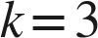. Find the copy's perimeter.
54 cm

2. A figure with area 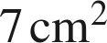 is scaled by . Find the copy's area.
63 cm²
Area × k² = 7 × 9.

3. A figure with area 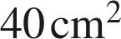 is scaled by 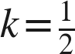. Find the copy's area.
10 cm²
Area × (½)² = 40 × ¼.

4. A 2 cm by 5 cm rectangle is scaled by 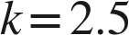. Find the copy's perimeter and area.
P = 35 cm, A = 62.5 cm²
P = 14 × 2.5; A = 10 × 6.25.

5. A figure has area 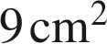 and its scale copy has area 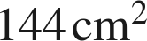. Find .
k = 4
144 ÷ 9 = 16 = k², so k = √16.

6. A figure's perimeter is 12 cm and its copy's perimeter is 48 cm. What is the area ratio, copy to original?
16
k = 4 from the perimeters; the area ratio is k² = 16.

